CNAR Search menu

CNAR Today Primary Menu

CNAR Secondary Menu
Big Read

As countries grapple with baby blues, what does a shrinking population mean?
From lonely deaths among the elderly to shrinking armies, falling birthrates are reshaping societies beyond the economic sphere.

The declining birth rate in many developed countries has led to a higher proportion of elderly people. (Illustration: CNA/ Nurjannah Suhaimi)
Listen
18 min

Taufiq Zalizan
13 Mar 2026 09:30PM (Updated: 20 Mar 2026 12:09PM)
BookmarkShare

Set CNA as your preferred source on Google
Read a summary of this article on FAST.
FAST
In Japan, over 76,000 people living alone were found dead in 2024, with about three in four such cases involving those aged 65 or older. And this "lonely death" crisis is set to worsen as the number of elderly living alone is expected to reach 10.8 million by 2050.
Across the ocean in Italy, expenditure from both public and private pensions is the highest in the world in terms of the proportion of the nation's gross domestic product (GDP) – standing at 16.6 per cent. Like in Japan, such spending is expected to only grow as Italy’s population shrinks and ages.
Meanwhile in South Korea, the country with the world’s lowest birth rate, its military has shrunk by about 20 per cent in the last six years. In terms of raw figures, it is 50,000 troops short of the number deemed adequate for maintaining defence readiness, said its defence ministry last year.
These are some of the grim outcomes in countries where the populations are shrinking.
No wonder then, that when Deputy Prime Minister Gan Kim Yong announced late last month that Singapore's resident total fertility rate (TFR) had hit a historic low of 0.87 in 2025, it prompted many heated discussions in parliament and online about what should be done to stem the tide of declining births.
A new workgroup was also announced to look into the matter, and it is fair to say that it has its work cut out. The nation’s TFR has been under the replacement rate of 2.1 since 1977, and since 2023 it has dwindled further to below 1.
If the decline continues unabated, the citizen population will start to shrink by the early part of the 2040s, Mr Gan said.

Related:


Singapore's fertility rate drops to historic low of 0.87 as country faces 'existential challenge': DPM Gan


How South Korea nudged its birth rate back up – and what Singapore can learn
More than half of the world's countries have fertility rates below the replacement point, with few able to arrest the decline, let alone reverse it, despite pronatalist policies such as financial incentives and better parental support.
Among the 38 Organisation for Economic Cooperation and Development (OECD) countries, seven have been facing shrinking populations since 2001, according to the organisation. By 2060, that figure is expected to double to 14, the OECD said.
Like Singapore, countries grappling with the problem have tried to counter slower economic growth from a shrinking workforce by raising labour force participation among residents and supplementing the labour supply with immigration and foreign workers.
While these strategies have worked so far, experts said that they have their limits.
Economist Walter Theseira noted that such policies are not new. In the Singapore context, they have been around since the 1990s, and he described them as "incredibly effective".
"Without these policies, over the last few decades, our population would have started to shrink, actually much earlier, and our labour force also would have started to shrink, actually much earlier," said the associate professor from the Singapore University of Social Sciences (SUSS).
However, there are limits on how far labour participation among the existing population can be stretched, and how much immigration the system can absorb.
Veteran economist Song Seng Wun noted that in developed countries the workforce participation rate among women and the elderly, for instance, is already higher than the global average.
"Eventually even if you can further bring up the percentage, you will still be limited by the math of the total population, which is declining," added Mr Song, who is an economic adviser at Singapore-based fintech firm SDAX.
As Singapore confronts what Mr Gan described as a "profound existential challenge", CNA TODAY looks at countries whose populations have already started to decline and how it has impacted their economies and societies.
More than half of the world's countries have fertility rates below the replacement point, with few able to arrest the decline, let alone reverse it. (Photo: CNA/Raj Nadarajan)

SUSTAINING ECONOMIC GROWTH
Conventional wisdom holds that a shrinking population will lead to economic decline by creating labour shortages and reducing domestic consumer demand.
However, the reality on the ground paints a more nuanced picture.
A study published in science journal Nature in October 2023 showed 19 countries with declining populations that saw positive economic growth between 1990 and 2019. The study noted, however, that 16 of these were former Soviet Union countries, which underwent significant economic reforms during the period, which boosted economic growth.
Separately, looking at seven countries with shrinking populations – China, Japan, South Korea, Bulgaria, Greece, Germany and Italy – CNA TODAY found that most of them recorded mostly positive GDP growth rates outside the COVID-19 pandemic years.
For instance, since 2014, China's annual GDP growth rates have been higher than the world's for 10 out of the 11 years, including 2022 onwards, after its population started declining.
Italy, which has experienced population decline since 2014, has continued recording economic growth too, albeit at a slower pace than the world average.
So, too, has Japan, whose population peaked in 2010, though it is notable that the East Asian country is still the fifth-largest economy in the world.
Assoc Prof Theseira from SUSS highlighted that even as the total population declines, the labour force itself may shrink at a slower rate.
"For many of the countries, they have a larger population of older persons, because fertility rates used to be higher in the past. So a lot of the population shrinkage is coming from that group, or in other words they are dying of old age. But it is not a one-for-one change to the labor force (as many of the elderly may not be working)," he explained.
Some of these countries have also been pushing for greater work participation among segments of the population that had previously not been in the workforce, experts added, such as mothers and the elderly.
These measures, along with the importation of foreign workers, can create a larger workforce to drive economic growth.
That is why, even though Japan saw a 3.2 per cent decline in population size from 2010 to 2024, its labour force grew by 5.14 per cent over the same period. In South Korea, its population size dropped by 0.17 per cent between 2020 and 2024, but the workforce grew by 5.17 per cent.
Mr Song added that technology and innovation also help to multiply productivity, and to a certain degree compensate for the decline in population.
But at the end of the day, the economists noted the limitations of such strategies in the long term. Immigration policies, for instance, are limited by public sentiment and the capacity of existing infrastructure.
Assoc Prof Theseira also pointed to the increasing demand for international talent and migrant workers in other countries, noting that it could become more challenging for Singapore to get the right talent in the required numbers.
In the long term, multiple projections indicate that economic growth across the world will fall over time due to demographic changes.
In 2025, the OECD estimated average GDP per capita growth among its member countries will drop from 1 per cent in the 2010s to 0.6 per cent annually between 2024 and 2060.
At the global level, the World Bank in 2023 projected that global potential growth will slow to a three-decade low of 2.2 per cent annually between 2022 and 2030, down from an average of 2.6 per cent in the period between 2011 and 2021.
A major part of this slowdown is attributed to demographic factors such as declining labour force participation due to overall shrinking population.
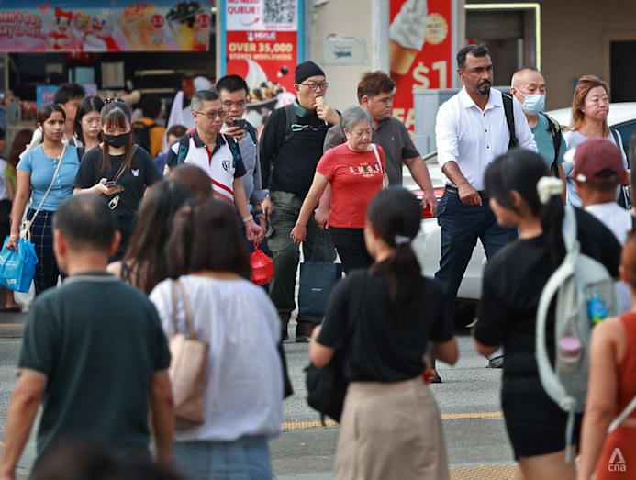A shrinking population is usually associated with economic decline,but the reality on the ground paints a more nuanced picture. (Photo: CNA/Raj Nadarajan)

COSTS OF A SHRINKING SOCIETY
Beyond its impact on economic growth, an ageing and shrinking population also imposes significant social strains.
- Financial support for silver generation
The old-age dependency ratio among OECD nations is projected to rise to 52 per cent in 2060 – meaning there will be 52 elderly for every 100 working adults – up from about 33 per cent in 2025.
Naturally, the rising cost of supporting an ageing population with an increasingly narrow base of younger workers to foot the bill is one major issue countries with shrinking populations have to contend with – something that Singapore is all too familiar with.
Singapore's spending on social development has already nearly doubled within a decade, from about S$31.3 billion (US$24.4 billion) in financial year 2015 to S$61.3 billion in financial year 2025. Experts previously told CNA TODAY that the increase was largely driven by the need to care for the nation's ageing population.
Countries with ageing and shrinking populations have seen how this heavy spending can take a toll.
In Italy, the European Commission noted that the average deficit in the nation’s pension system – meaning the difference between contributions and gross expenditure – is expected to be "more than 4 per cent of GDP" for the period between 2022 and 2050.
In Japan, much like in Singapore, its social security expenditures earmarked in its 2026 budget rose to a record of JPY39.1 trillion (S$313.6 billion), or about one-third of all government spending.
- Evolving social support structure
Beyond costs, the changing population structure gives rise to other social challenges as well, especially in terms of social support for the elderly.
Where previous generations had bigger households and more family members looking out for one another, many old folks in ageing and declining populations today end up living alone with small social or familial networks.
Loneliness and isolation in itself is already linked to negative impacts on health and even risks of early death, according to the World Health Organisation. The lonely-living situation has even led to many cases of the elderly dying undetected.
In South Korea, there were 3 million single-person households comprising those aged 60 and above in 2024. By 2049, more than half of all single-person households will be aged 65 or older.
In 2024 more than 1,400 funerals in Seoul had to be funded by the public as the bodies were unclaimed – a big jump from 382 such cases in 2018. Almost eight in 10 of deaths with unclaimed bodies involved the elderly.
Dr Kalpana Vignehsa, from the Institute of Policy Studies (IPS), said that as the TFR declines and family structures become narrower, the burden of caregiving of the elderly and family members will also evolve.
"It's not that the caregivers did not used to experience strain in the past – it's just that they tended to have more people to share the caregiving burden with," she said.
"As a society, there's a ripple effect of people having fewer children in terms of how we support one another, and then needing to draw on more support from state services to fill in the gap."
Hence, she said, as even more women pursue their career and financial goals and more family units see both parents working, there needs to be greater support from society as a whole to help those who want to have children be the best parents they can be.
"If society doesn't factor that into that calculus, into how we behave with our colleagues, how organisations and companies behave with their employees, then, of course, it could lead to a further decline in the TFR," added the senior fellow in the governance and economy department at IPS.
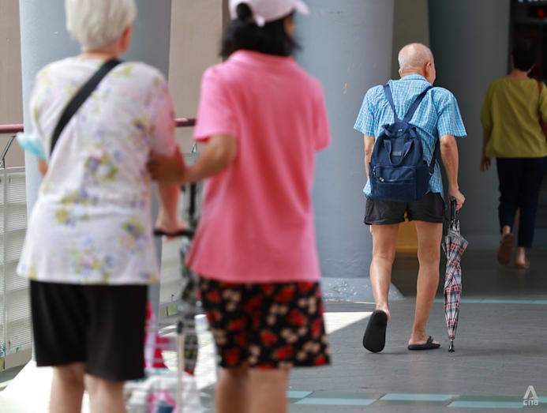The rising cost of supporting an ageing population with an increasingly narrow base of younger workers to foot the bill is one major issue countries with shrinking populations have to contend with. (Photo: CNA/Raj Nadarajan)
- Infrastructure and manpower blues
Shrinking populations also have implications for physical access to public services and the upkeep of infrastructure.
This is particularly so when the decline in population numbers is coupled with migration either into urban areas or out of the country outright.
For instance, today there are many old houses up for sale in various parts of Japan and Italy, particularly in the rural areas, at attractive prices. Such houses in parts of Italy can go for as low as 1 euro (S$1.5).
However, many of these houses are in a decrepit state and require extensive renovation and upkeep works.
More importantly, though, many neighbourhoods in which those houses are located also lack the provision of public services.
For instance in Mussomeli, a town in Sicily, Italy, it was reported how an Argentinian family snapped up and moved into one of the 1-euro houses two years ago, only to find that the local hospital was at risk of closure due to a lack of staff.
In Bulgaria, access to general practitioners is vastly unequal across the country, owing to the uneven decline in population across the regions, according to one OECD report in 2021. The ratio could vary from as high as 3,000 residents per doctor in a rural, southern area to 1,200 per doctor in a metropolitan area in the north.
Meanwhile, as geopolitical conflicts have flared up around the world in recent years, the impact of a shrinking population on a nation's defence capabilities naturally comes into focus.
Mr Thomas Lim, an associate research fellow from the S Rajaratnam School of International Studies, told CNA TODAY that this issue is becoming "rather common".
"Quantity is a quality of its own, especially so in the realm of defence and security," said Mr Lim.
"You want to make sure you have enough people coming through your training hands so that you can train each batch to take over their roles in defending the nation, and to ensure a healthy flow of force turnover year-on-year, such that all of the state's defence needs are properly manned or attended to."
Some countries try to stem this issue by reintroducing previously-abolished conscription, like Latvia, he noted.
Facing such manpower shortage issues, countries including Singapore are turning to job redesign and investing in technology, among other things, in an effort to maintain a similar level of military capability with a smaller headcount.

Related:


How Singapore is preparing for a super aged society come 2026


The Big Read: With more seniors in Singapore needing care, is assisted living the answer?

DOES A SMALLER POPULATION HAVE ITS UPSIDES?
Despite the well-documented concerns about dwindling birth rates and declining population, there are those who argue that there may be a silver lining to it all.
For one thing, a tight labour supply due to a shrinking population could lead to higher wages. In Japan, for example, it was reported that major firms last year agreed to big wage hikes amid tightening labour conditions.
In Singapore, Assoc Prof Theseira highlighted moves to increase wages for bus drivers as an example.
"The impetus is the shortage of Singaporeans who are willing to do this work," he said. "Without that shortage, will they want to move as quickly on raising conditions and wages? Maybe not."
Given how many of the environmental issues that the world faces today can be attributed to overconsumption by the human population, there are some who argue that a smaller human population would be better for the planet.
According to a 2017 study from researchers in Lund University in Sweden, a family having one fewer child could reduce carbon emissions more effectively compared with other actions such as living a car-free life, cutting down on air travel or switching to a plant-based diet.
Furthermore, a common refrain when discussing population size in the context of a densely populated city like Singapore is that having fewer people could lead to better quality of life due to reduced congestion and less strain on infrastructure such as public transport.
Some, such as RSIS senior fellow Han Fook Kwang, contended that Singapore's dwindling population can be viewed as an opportunity to "improve the capability of the people and enhance their livelihood".
One possibility is to make world-class standard childcare and preschool education in Singapore completely free, he said in a commentary for CNA.
"If people know that their children’s education will be taken care of in the first six years by the government, and up to world class standards, will it not nudge them to have larger families?"
Indeed, according to a 2025 study published by scholarly journal Duke University Press, a smaller cohort could mean that more public resources are available per child, thus benefiting the youngsters.
However, the paper also noted that this is contingent on resources remaining at their current levels rather than being scaled down in response to smaller cohorts.
Promising as these views may sound, experts cautioned that the perceived benefits of having a smaller population are not as straightforward as they appear.
On education, Dr Kalpana said that investing more into each child can already be done today – such as by hiring more teachers to keep a smaller student-teacher ratio in the classroom – without needing the birth rate to decline further.
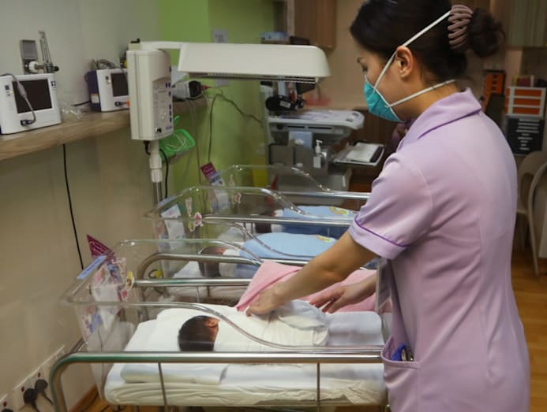Some argue that there may be a silver lining to a declining population, but experts said that it is not so straightforward (Photo: CNA/Raj Nadarajan)
On infrastructure, some experts noted that while having fewer people using an existing service like a metro line may enhance the user experience, a certain critical mass is required to justify the provision of such services in the first place.
In Singapore's context, the experts pointed to the many schools that have been closed or consolidated due to dwindling enrolment, and noted how new estates often lack public transport connectivity until they are fully populated.
Dr Kalpana argued that beyond just looking at numbers and rates, society in general simply needs its younger generation to function – from generating growth for the economy to coming up with ideas and innovations that benefit society as a whole.
"When we talk about population decline, we also … have to imagine a kind of bleaker society that doesn't have that injection of new ideas, new innovation, what I call social renewal."
Ultimately, a declining fertility rate and population number will have significant long-term repercussions, which cannot be easily reversed, experts stressed.
"The thing about population (decline) is that it compounds. So the decline is very sharp, and it's very difficult to go from (a TFR of) 0.5 to 2," said Dr Kalpana. "We still don't have examples of societies where TFR dropped below 2, and then sustainably returned to 2."
"Looking at it demographically, the problem with asking: 'Is there any upside?' is that, well, unless you are okay with eventual extinction, it's very difficult to see that there is an upside."
In the meantime, Assoc Prof Theseira said that in Singapore's context, while it is not completely impossible to generate jobs and economic growth without growing the population, overall it is still beneficial for the population to expand.
"When there's a growing population, there's more business. And quite a significant chunk of our workers will benefit in one way or another from it."

